## Oscilar

Demo date:   
Scoping start date: Nov 6, 2023

MSA Signature Date: Feb 7, 2024  
Onboarding Kick Off Date: Jul 11, 2024

[If Exists] Opt Out Date:  
Go Live Date: Aug 1, 2024

GTM POC: Jarrett  
Implementation POC: [Arjun Gopalratnam](mailto:arjun@tabs.inc) and [Ariel Bernstein](mailto:abernstein@tabsplatform.com)while Arjun is ooo

ERP: QBO

Tax Integration: No Tax

### 

### Key people at Merchant

### CEO: https://www.linkedin.com/in/nehanarkhede/

### Accountant: <https://www.linkedin.com/in/kari-cook/> (Fractional from Attivo)

### EA: Cami

* Dev: Ram

Primary mode of communication: #oscilar-tabs-ext

### 

### Company summary

Oscilar is a no-code, AI-powered risk decisioning platform that helps fintechs manage fraud, credit and compliance risks.

Goals (North star)

Tabs is solving their usage tabulation issue  
  
AE Notes

Any important relationship information  
  
1) What is Merchant Temperament? Neha is a destroyer of world. She prexist time itself  
2) Is there key POC the buyer/decision maker? Neha who may defer to Kari   
3) What are the Tabs features the key POC care about? Usage tabulation

### Billing model

* Platform Fees: Billed monthly, quarterly, or annually based on contract.
* Usage Fees: Billed monthly in the second half of the month after Tabs receives usage reports. Usage fees are invoiced separately from platform fees.
  + Minimum commitments may be billed upfront on a monthly, quarterly, or annual basis
  + Usage may also be billed based on actual consumption (e.g., usage through a 3P reseller)

### Contract Processing Steps

1. Contract ingest [FOR US TEAM REFERENCE ONLY; PLEASE IGNORE OTHERWISE] – Oscilar has an integration with Docusign where documents are sent to us automatically when they are closed-won. Sometimes we get early versions of these docs. Please ignore emails unless they say COMPLETED: on the subject and have a PDF attached. That should reduce the chance of duplication.  
    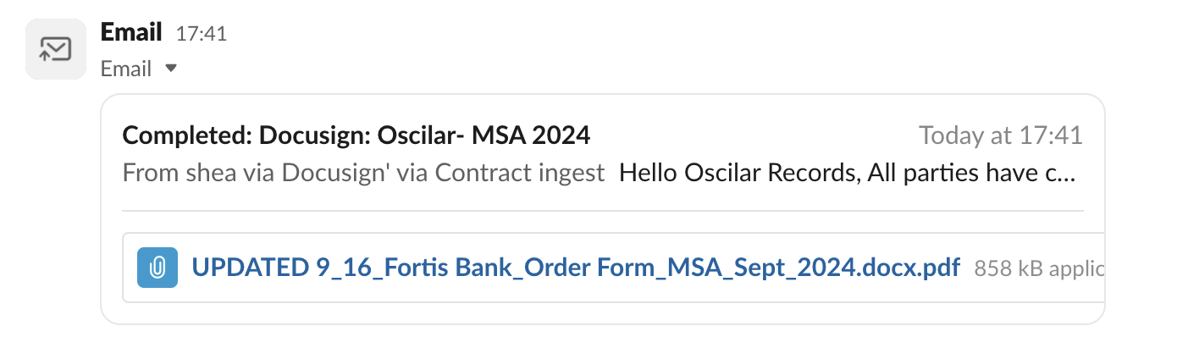  
   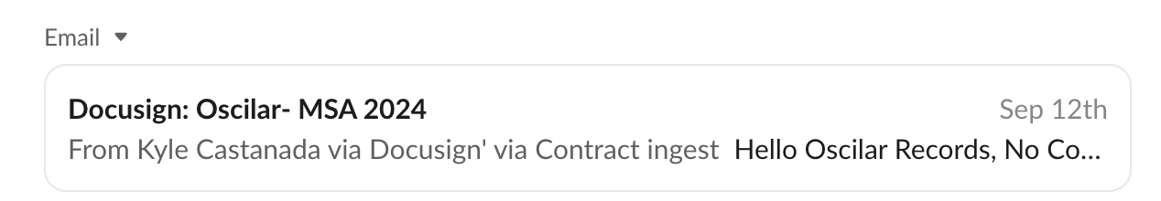
2. ~~DO NOT CREATE CUSTOMERS FOR THIS MERCHANT. Instead, inform~~ [~~GS Suri~~](mailto:gssuri@tabsplatform.com) ~~when a matching customer does not already exist and he will provide next steps.~~
   1. ~~Please provide customer creation details in your message.~~
   2. Please make sure when creating customers, that billing email is the one used to create customers
3. Contract Interpretation & Obligation Structuring
   1. Avoid splitting obligations unnecessarily (e.g., when multi-year contracts are split into quarterly terms). For example, pls see the below image and AVOID doing that. NO NEED TO SPLIT BTs by Quarter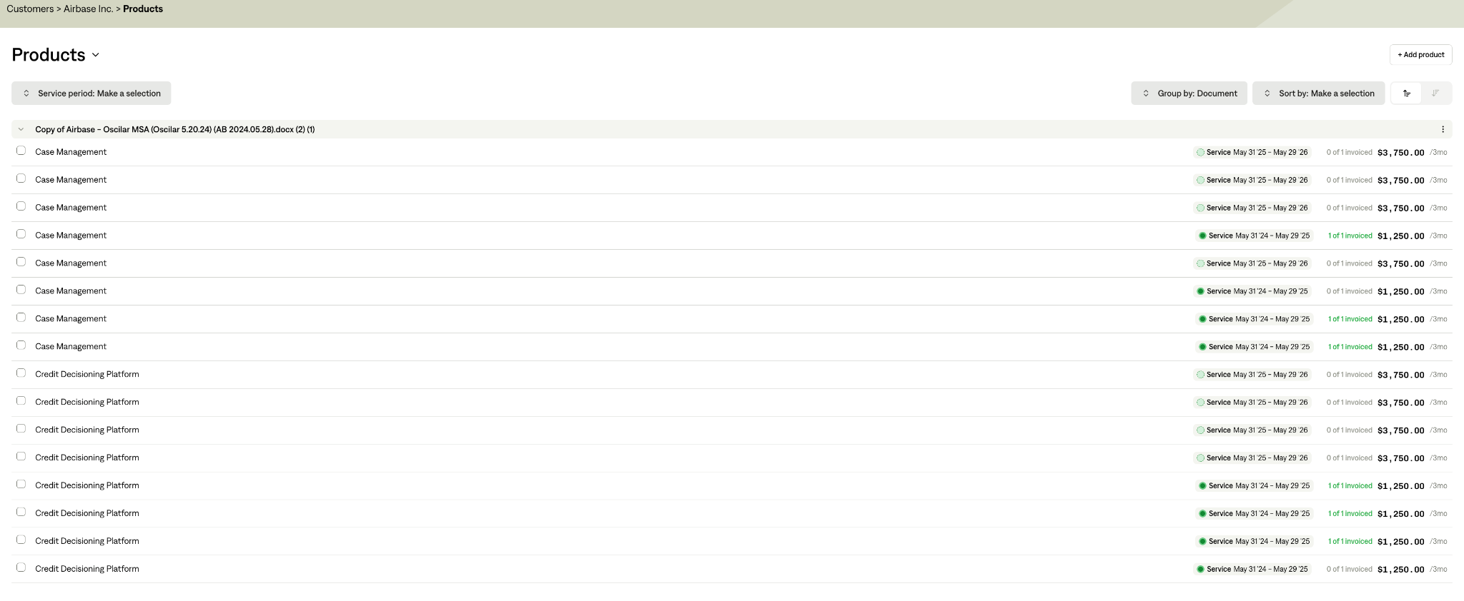
   2. Align revenue schedule with billing schedule – Make sure rev rec matches the full billing term where appropriate (e.g., not defaulting to 1 year on 2-year prepaids)
      1. If one year contract, create a single revenue schedule covering the whole year.
      2. Add a billing term that is recurring and covers the amount and frequency stated in the contract.
      3. If two year contract, there may be a ramp-up in price and credits between year one and year two. In this case, create two revenue schedules, one for each year.
4. Do not write out the number of credits or seats that are included by each product.
5. Naming
   1. Full SKU name should be in title (Fraud Platform, Credit Decisioning Platform, etc.)
   2. No “Annual Fee” in front of SKU name, just the SKU name
   3. No need to put anything like “quarterly payments” in description
6. Add on documents - sometimes customers will add more products/services mid term
   1. Create new BTs if effective dates are different, and of course if there are new SKUs
   2. Combine with previous BTs from original contract ONLY IF effective date and skus are all the same
7. If a specific split is mentioned, such as 40/60 for biannual payments, following the percentage split when dividing the line items. This will be located after the terms and above the signature in the 2 tables that outline line items and costs.

In the example below:

First payment would be: 40% of 406,000 + 40% of 15,000 = 168,400

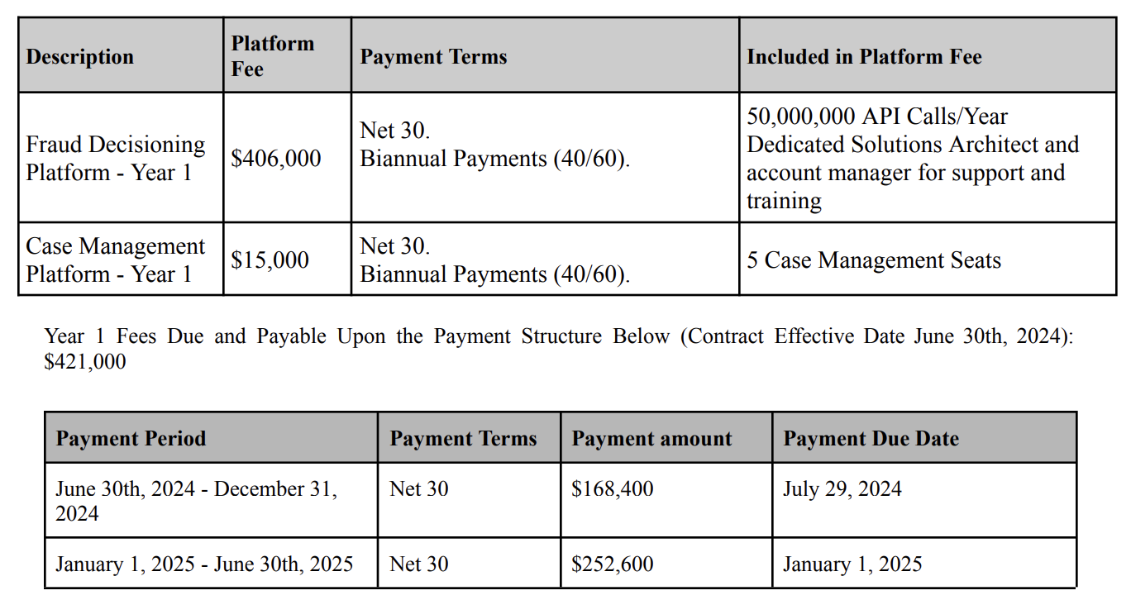

1. Proration:
   1. SKUs always need to be broken out into individual line items, so if there is a ramp up payment schedule defining payment totals for each payment date, then each SKU needs to be prorated.
   2. Example: 3 SKUs in this package that all need to be broken out, but the first two payments of each SKU are different amounts than the second. These amounts are calculated by prorating based on the total payment around for that period
      1. [Contract: Unity Plus](https://garage.tabsplatform.com/prod/contracts/40465c31-c832-421f-b2e1-db12fcdaa45c/preview)

Calculation for Credit Decisioning SKU for first 2 quarters:

Q1 total **16000** / Total amount **106000** = Percentage of SKU total needed to be billed **0.1509434**

Credit Decisioning total **41000** x **0.1509434** = Credit Decisioning total for Q1 **6188.67925**

This would need to be done 6 times, 3 for each SKU for the first 2 quarters and 3 for each SKU for the second 2 quarters

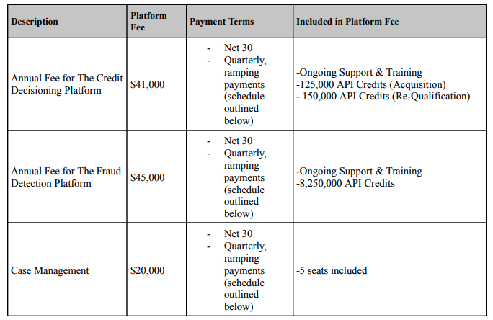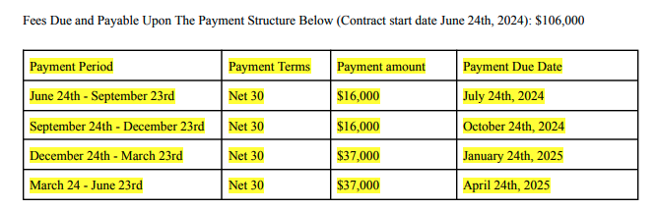

1. If there is a Monthly Minimum, Usage AI will need to be turned on



* 1. What is the Monthly Minimum?
     1. The customer will always pay at least the monthly minimum — if their usage is lower, they’ll be invoiced for the full minimum after the month ends, and if their usage exceeds it, they’ll just pay the higher amount.
     2. We need to set up usage AI to automatically invoice the full minimum at month-end whenever usage falls below it.
  2. Do not process the monthly minimum as a separate BT. It will only be captured by the usage AI module
  3. Process all usage BTs

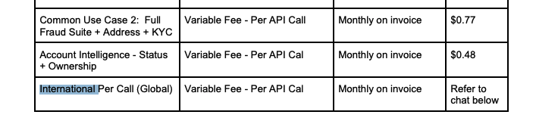

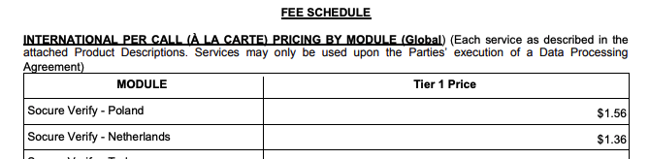

* 1. Click on **5. Usage AI** in garage
  2. Select **Has usage requirements** and **Has Minimum**

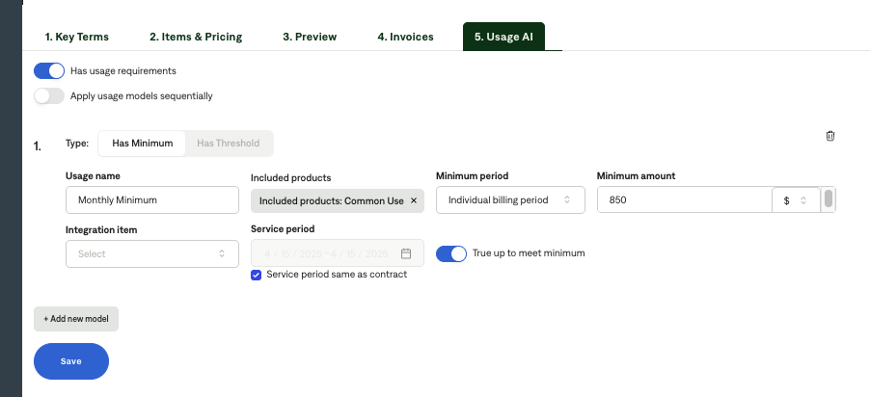

* 1. Usage name: Monthly Minimum
  2. Included products: select ALL usage products
     1. You will select these in a dropdown
  3. Select individual billing period for minimum period
     1. This will cause the monthly minimum to track each billing period for the usage BTs
     2. So if there is a monthly API call usage BT, the minimum amount will apply each month since the BT is set up to occur monthly
  4. Select “True Up to Meet Minimum” button

1. Default Service Term
   1. 1 year
2. Default Net Payment Terms
   1. Default all to Net 30
3. Default Billing Frequency
   1. Annual

### Events Processing (if necessary)

* TBD – do not process any events for now. We will come back and write the MIS for this after Aug 1, 2024.

Integration Items Processing (if necessary)

* General Rule: Use “Oscilar programs:” and match to language in the sku in the integration item
* Specific mappings:
  + Professional Services = Oscilar Programs:Oscilar Professional Services
  + Credit Decisioning = Oscilar Programs:Oscilar Credit Risk Platform
  + Fraud Platform = Oscilar Programs:Oscilar Fraud Risk Platform
  + AML Platform = Oscilar Programs:Oscilar AML Risk Platform
  + KYC/KYB = THEY NEED TO ADD

Post Processing Communications (if necessary)

* Notify merchant and tag @Kari on slack channel #oscilar-tabs-ext

### Customer Information

* None

### Feature Requests

* None

### Rewatch Calls

https://tabs.rewatch.com/video/gwrxbelymy6q3w4i-oscilar-tabs-demo-june-12-2024